Maer Village Newsletter

Village website – www.maervillage.co.uk

Village Hall Registered Charity Number: **503432**

Summer 2019

**Village Hall Committee**

Our next meeting is Monday 9th September at 7pm. If you would like anything to be discussed or would like to join the committee please contact the Secretary - [sue.jackson521@gmail.com](mailto:sue.jackson521@gmail.com)

**Yoga with Pip**

The summer session is one mixed class at 6.45pm-7.45pm in the village hall. Normal times returning on 6th September. 6pm (slow and steady) and 7.15pm (improvers) – further info on the website

07902660814 or [www.yogawithpip.com](http://www.yogawithpip.com)/event

**Pilates classes**

A new Pilates session will be starting in Maer Village Hall on Friday evenings, from 7 – 8 pm, beginning on 9th August. The sessions are primarily aimed at Pilates for riders but all are welcome. The cost is £8 a session or £36 for a 6-week course. More details from Sammy Bloor, 07543636239, email: [sammyebloor@gmail.com](mailto:sammyebloor@gmail.com)

**Staffordshire Wildlife Group**

The first talk of the winter series is on October 11th on Northumberland Wildlife. See attached poster.

**Harvest festival**

Harvest Thanksgiving will be on Sunday 22nd September at the 9.30 am service and the splendid Harvest Supper will be the next day, Monday 23rd September at 7 pm in the Village Hall. This is usually a sell-out, so if you’re considering coming to the Harvest Supper, it is worth giving your names to Wendy (680613) now!

**Garden Guild**

The Garden Guild are holding their annual produce competition on Monday 19th August at 7.30pm. Everyone is welcome to come and view the displays of fruit, flowers and veg.

**\*\*\*Neighbours day\*\*\*\***

We have decided to hold another event on **Sunday 27th October 2019** when we hope to get together with existing, new and old neighbours from our community.  As before we will be providing tea, coffee, orange squash and a range of delicious cakes.  This event will run from **2pm-4pm at Maer Village Hall** and as previously, and is also free of charge.

**NEWS**

**Midsummer in Maer**

Midsummer in Maer’, a free event organized by Maer Church Council, took place on Friday 14th June. The Church was full; the music was great and the refreshments plentiful. What better way to spend a summer’s evening?

**Village hall flowers and gardening**

The flower boxes are looking resplendent at the moment. Many thanks to members of the Garden Guild (Janet/Peter) for creating such fabulous displays

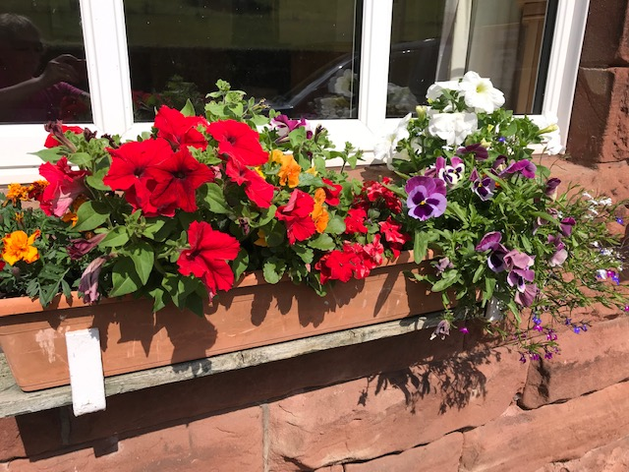

In the past couple of weeks we have had a gardener come to tidy up all around the hall and trim the hedges – fantastic job

**If anyone would like to offer their service or help with future maintenance of the surrounds of the hall, then please contact members of the village hall committee.





|  |  |
| --- | --- |
| future dates for your diary  **27th Sept – The Mighty Quiz**  **11th Oct – Staffs Wildlife Talk**  **27th OCT – NEIGHBOURS day**  **16th Nov – The Autumn Fair** | |
|  |  |
|  |  |



**The Mighty Quiz 2019**

Our third year of running a quiz night to raise money for Alzheimer’s research

Various quiz rounds on general knowledge, music, sport and an opportunity to show off your creative skills!!!!

Maer Village Hall, Maer

Friday 27th September 2019

Prompt start At 7.00pm

Teams of up to 6 people welcome

Tickets £15 per person including Fish and Chip Supper

**Raffle, spot prizes and team prizes available**

Please contact Sue Jackson to book your team table

01782 680521

[sue.jackson521@gmail.com](mailto:sue.jackson521@gmail.com)



**Friday 11th October 2019 at 7.30pm**

**Maer Village Hall, ST5 5EF**

THE WILDLIFE OF NORTHUMBERLAND

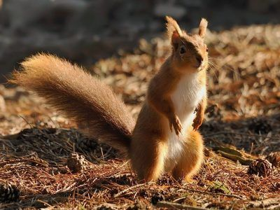

An illustrated talk

by Mike Baskeyfield

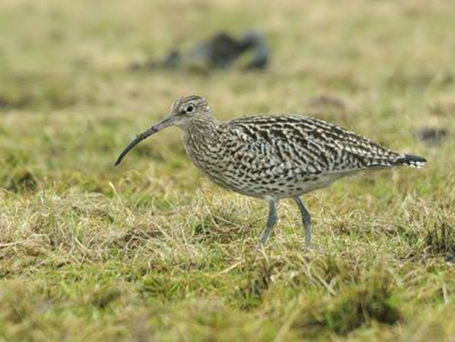

Kindly sponsored by Brookfield Farm Shop, Blackbrook

Northumberland is packed with stunning wildlife, rich in diversity and well worth seeing. There are two areas of outstanding natural beauty, on our coast and covering the North Pennines, as well as Northumberland National Park packed to the brim with rare plant and animal species.

Admission £3 includes refreshments. Children free, Non-members welcome

Village Activities/Groups

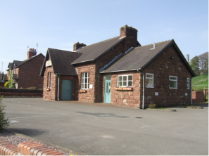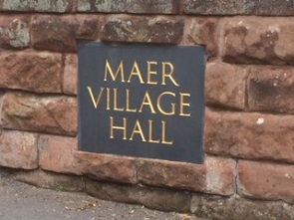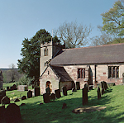

**Parish Council (Maer and Aston) -** www.maerastonparishcouncil.co.uk

The Parish Council meetings are open to everyone in the Parish.

The next meeting is on 17th September held at Aston Village Hall at 7.30pm

Your local councillors are Linda Chesterton, Pat Stanier and Elena Sudlow (clerk)

Please contact them via the website to discuss any local issues or suggestions

**\*\*\*\*PARISH COUNCIL OPEN SESSION\*\*\*\*\***

Maer & Aston Parish Council meets regularly each month and every meeting is open to the general public to attend.  It is unusual for us to get many visitors however which means that most of you probably do not know how the Parish Council operates and what we do.  Each year your Council tax bill arrives and you have a Parish rate as part of this bill.  This money is used by the Parish Council.

At our meeting on **October 17th** we are holding an '**Open Session**' from **6pm-7.30pm** when the Clerk and  Councillors will be available and we hope to show how the Parish rate is spent, what issues we get involved in and also to hear if there are any issues you would like us to help with.

Please come and join us for some light refreshment on Thursday 17th October at Aston Village Hall.  To ensure that Maer residents also have an opportunity to see how the Parish Council works, the information and Councillors will also be available at the Neighbours' Day event at Maer Village Hall on Sunday 27th October from 2-4pm.

**Conservation area news**

Maer village is listed within a specific conservation area – this website gives guidance and further links for conservation areas and application forms

<https://www.newcastle-staffs.gov.uk/all-services/planning/conservation-and-heritage/conservation-areas>

**WI**

The next meeting is at Maer Village Hall at 7.30 on **August 14th**

Pat Hall - “Quirky  Quartets” !!!!!   - quick change comedy sketches  ...ladies  such as credit crunch, lottery winner, nil by mouth, Lady Walter Raleigh  share their problems serious to them, but humorous to the audience. First world war ladies - Lady Cynthia Plunket Green, Mrs Ivy Crumpstall, Daphne Arbuthnot MBE, Miss Vera Bottomley reading letters to a loved one may also be featured. Four Characters will be chosen, then observational comedy written by Pat Hall, the speaker.

**Church services are as usual:**

1st Sunday of the month – 8 am, Holy Communion.

2nd Sunday - 9.30 am Family Service

3rd Sunday - no service at Maer. 9.30 am at Chorlton

4th Sunday - 9.30 am Family Service.

The Church is usually open during the day – a beautiful and peaceful (and cool!) space for all to enjoy